**SMART STAR EXAMINATIONS BOARD**

**END OF TERM ONE EXAMINATION - 2024**

**READING**

**TOP CLASS**

My name is…………………………………………

1. **Write the first sound for the picture.**

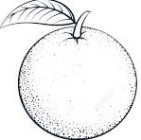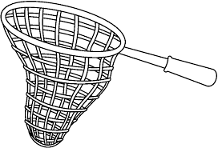

_______ _________

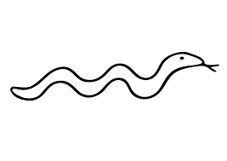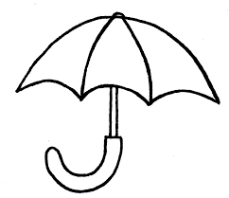 _______ _________

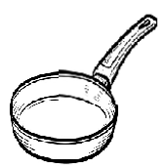

 __________ ________

1. **Tick for the word.**

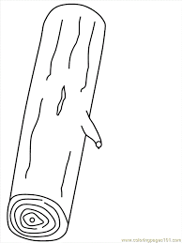

|  |  |
| --- | --- |
| log |  |
| vest |  |
| stick | Related image |
| egg | **Related image** |
| van | D:\IMAGES\girl.png |

1. **Name the pictures.**

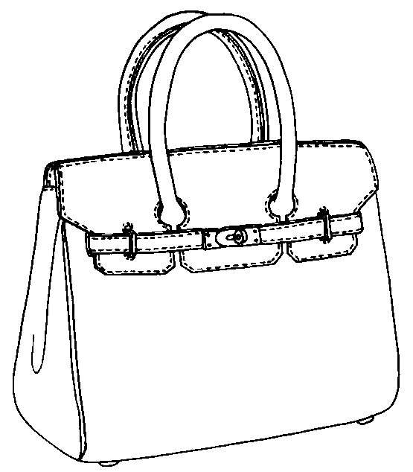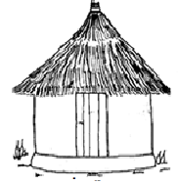

________ __________

D:\IMAGES\hat.png

_______________

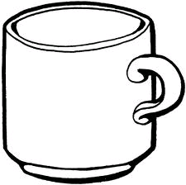

1. **Make sentences using “It is a ________”**

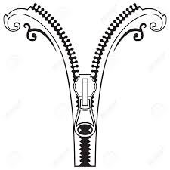 It is a zip.



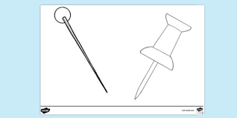



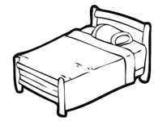

1. **Read and match.**

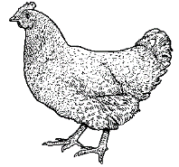a doll

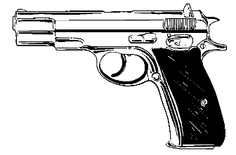 a rat

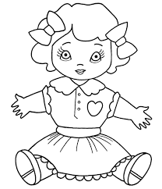

a hen

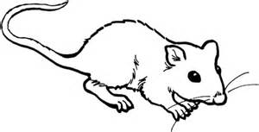

a gun

1. **Join the dots.**

**a**

**e**

**i**

**o**

**u**

1. **Read for teacher.**

**It is on**

**It is at**

**As it is**

**It is in END:**